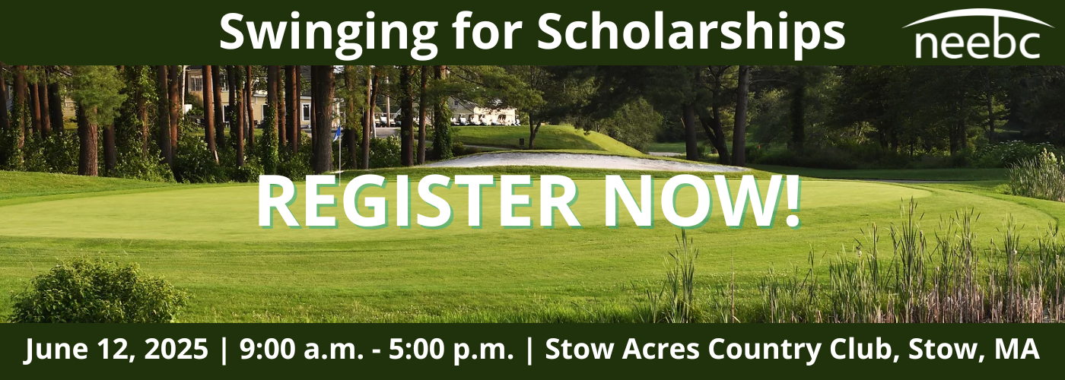
Golfer Registration Deadline: Friday, June 6, 2025
SPONSOR SELECTION
Master’s Level Sponsor (capped at 2) - $3,000  (Includes 2 foursomes; kick off scramble with welcome message; tee sign; cart sign; golf balls (provided by sponsor) with sponsor’s logo in goodie bags; aggregated sponsor sign & entry in raffle) | ☐ | $3,000
Ryder Cup Sponsor (capped at 4) - $1,750  (Includes foursome; tee sign; cart sign; aggregated sponsor sign; entry in raffle) | ☐ | $1,750
Lunch Sponsor (capped at 1) - $1,500  (Includes sponsor sign at the turn; aggregated sponsor sign; entry in raffle | ☐ | $1,500
19th Hole Sponsor (capped at 2) - $1,000  (Includes option for 3 minute speaking opportunity kicking off the reception; aggregated sponsor sign; entry in raffle) | ☐ | $1,000
Tee Sponsor (capped at 18) - $150  (Includes tee sign; entry in raffle) | ☐ | $150
Continue to Golfer Registration on Page 2

GOLFER SELECTION (Non-Golfers can sign up for reception and/or make a Scholarship Donation in the Registration Fees section).
Choose an item.

# | GOLFER NAME | COMPANY | ADDRESS | EMAIL | PHONE NUMBER
1 | _____________________ | _____________________________ | _____________________________ | _____________________________ | _________________
2 | _____________________ | _____________________________ | _____________________________ | _____________________________ | _________________
3 | _____________________ | _____________________________ | _____________________________ | _____________________________ | _________________
4 | _____________________ | _____________________________ | _____________________________ | _____________________________ | _________________
5 | _____________________ | _____________________________ | _____________________________ | _____________________________ | _________________
6 | _____________________ | _____________________________ | _____________________________ | _____________________________ | _________________
7 | _____________________ | _____________________________ | _____________________________ | _____________________________ | _________________
8 | _____________________ | _____________________________ | _____________________________ | _____________________________ | _________________

REGISTRATION FEES
Sponsor Amount (see page 1): | $_____________
Golfer Registration Amount (see top of page 2): | $_____________
Scholarship Donation (optional): | $_____________
Reception (19th Hole) Only ($25 per person): Name: ___________________  Company: _________________ Address: ___________________________________  Email: _________________ Phone: ___________________ | $_____________
*TOTAL: | $_____________

PAYMENT INFO
*Payment Options: Choose an item.
Pay by Credit Card: Total Amount $__________________
Type: Choose an item. CC Number: __________________ Exp (MM/YYYY): __________________
Security Code: __________________ Zip code associated with the credit card: __________________
Name exactly as it appears on credit card: __________________
Main Contact (if different from golfer #1):
Name: ___________________ Company: _________________
Address: ___________________________________
Email: _________________ Phone: ___________________
Instructions:
- Download the registration form, complete and email it along with payment information to admin@neebc.org.
- Call the NEEBC Office with your questions or for assistance: 781-684-8700.
We look forward to seeing you on Thursday, June 12, 2025. Thank you for supporting the NEEBC Scholarship Program!

